CS320 Project 2 Summary and Reflections
Tyler Spitz
2-20-26

Summary
Over the past few weeks, we have been tasked with developing and testing back-end services for a mobile application. Throughout the assignments, I picked up various techniques to define my testing approach. I used JUnit 5 test cases to validate functionality of my service components to ensure that all software requirements were satisfied. For the Contact service component, my tests consisted of many requirements such as valid contact identifications, non-null inputs, lengths of characters, phone numbers that had to be only 10 digits. Additionally, I tested execution of various methods like adding contacts, removing contacts, updating contact information to demonstrate service integrity.
The Task Service tests involved validating identification numbers, updating descriptions,
checking description lengths, and checking for null values. For the Appointment Service, I had to test for date validation and make sure the date is not in the past for appointment creation. Appointment ID numbers had to follow similar constraints as the Task and Contact services as well. With all the service components my approach involved testing valid inputs, boundary conditions like with length of strings, and invalid inputs using assertions. My technique proved effective when I could see that all my software aligned with the requirements for each service. The specified requirements were as follows:
- Identification numbers could not exceed 10 characters and could not be null.
- Strings specific to services have maximum lengths and cannot be null.
- Appointment Dates could not be in the past.
So, I knew that my tests had to be explicit and meet all those requirements for each service.
An example of one of my tests for a null description:
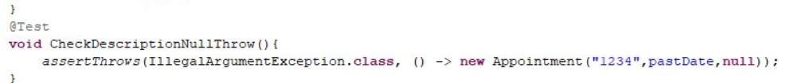
I used an assertion to verify the correct behavior of my method within the appointment service:
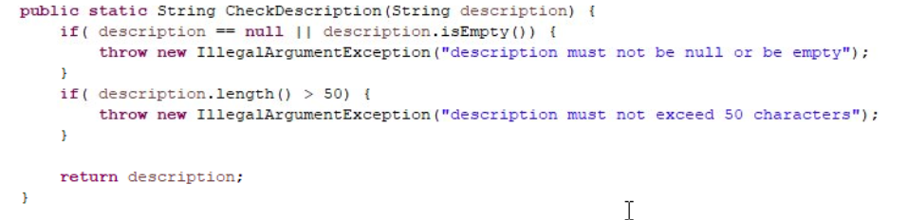
You can see I have an IF statement checking for a null description and when my test executes it will throw the illegal argument exception as expected. This demonstrates an alignment between the software’s functional requirements and my system’s behavior.
Checking for the coverage of my JUnit 5 tests I achieved an 80% coverage overall satisfying my requirements. With 80% coverage, this indicates that a large portion of my lines were executed and tested. As for the quality of my tests, I made sure to test for failures as well as successes. I used assertions to demonstrate adequate defensive programming. I maintained my code to be efficient by use of annotations @BeforeEach. You can see below how I used @BeforeEach to set a past and future date for the Appointments testing to test against:
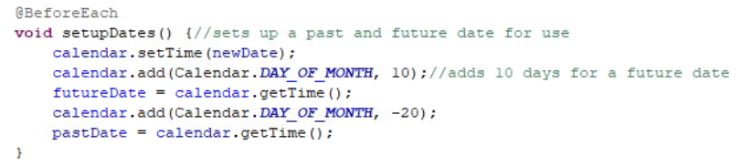
This helps keep my code clean and avoids repetition by preventing the need to declare dates in every test.
Reflection
Utilizing JUnit 5 testing requires a deep understanding of requirements to be effective. With each test I tried to keep them simple in testing only a single responsibility to ensure clarity and organization. Below you can see I used @Test annotations and appropriately named methods:
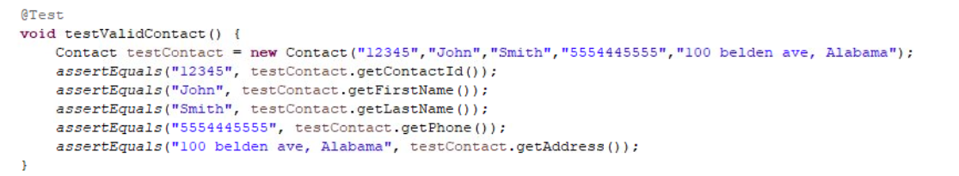
This verifies object validity and checking for correctness using assertion assertEquals.
As mentioned, I used defensive programming assertion assertThrows to test for intentional failures and to ensure efficiency I used annotation @BeforeEach for a reusable setup pattern. This proves technical soundness by verifying the constructor correctly assigns state and no unintended mutations occur. By practicing Unit testing I was able to achieve fast execution, automated validation and independent small tests. There were a few techniques not used within this project. Integration testing for testing interactions between components which is great for larger applications. System testing which tests the system as whole. Acceptance testing for validating user expectations but not needed for a small service application. The practicality of testing using these techniques would come down to the type of project. My mindset throughout this project was “how can I break the code” in a nutshell. In my personal experience, developing my own game applications, there are numerous ways a user will interact with your software and its important to test many different scenarios to ensure a high quality experience. However, even with my game application, I can say I have bias because the way I would interact with my software will be different for someone else. I say this because it shows that having testers separate from the software engineer will ensure that the system is built for general use not just that engineer.
My discipline comes from my commitment to the quality of my code. My stance on it is if I maintain great quality I can hold myself accountable to avoid technical debt and inefficiencies. I then can maintain reliable and scalable code.

